Module 1.1: Is This Your Calling?

Advocating for Effective Supervision

Understand best practices in peer supervision to know what you can expect.
The Substance Abuse and Mental Health Services Administration (SAMHSA) offers a brief self-assessment called the Supervisor of Peer Workers Self-Assessment that offers supervisors a chance to reflect on their practice and identify opportunities for growth. Peers can review the items to consider if their supervisor embodies the assessment’s 11 key knowledge and skills. It can be helpful to remember that just as you are growing professionally in your role, ideally, your supervisor is taking steps to do the same.
The assessment shows that supervisors should be able to:
Supervisory Knowledge and Skills
- Clarify organizational systems, structures, and processes
- Understand the values and practice of peer support
- Understand the roles and responsibilities of peer support workers
- Maintain a balance between the administrative, education, and supportive functions of supervision
- Establish a relationship characterized by trust and mutuality
- Provide an environment that promotes reflection on peer support practice and ethics
- Help a peer set and plan for the achievement of professional goals
- Teach and model skills needed for effective peer practice
- Deliver strengths-based supervision and use affirmations
- Give feedback that assists the person in recognizing a professional development need
- Advocate for recovery-oriented services within the agency
For those interested in a deeper dive into what high-quality supervision covers, the National Association of Peer Supporters’ (NAPS) National Practice Guidelines for Peer Specialists and Supervisors outline both the peer and supervisor roles for each of their 12 core values. The Georgia Mental Health Consumer Network also created a Supervisor Guide: Peer Support Whole Health and Wellness, providing an overview of peer supervisor skills and capabilities.
[Insert graphic regarding peer role/supervisor role from referenced document]
Here is one example of the NAPS guidelines provided for Core Value 1. Peer Support is Voluntary.
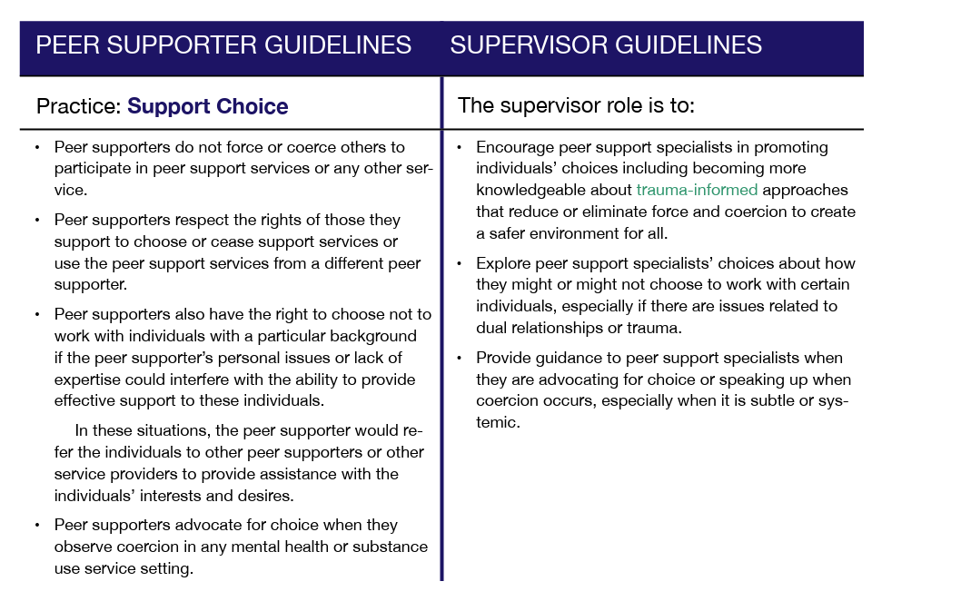

Request a Supervision Agreement from your agency that outlines expectations; document the outcomes of your supervision meetings to keep a record.
Having a written Supervision Agreement that details a shared set of goals, responsibilities, and rights between the peer and their supervisor can help set clear expectations and identify any critical gaps in current supervision. If your organization already has a Supervision Agreement form, review it carefully to see if it covers the best practices previously discussed.
Once you have an established Supervision Agreement that aligns with best practices, you are in a knowledgeable and strong position to constructively point out to your organizational leadership where improvements are needed.
The City of Philadelphia Department of Behavioral Health created a Peer Support Toolkit that provides a Supervision Agreement template and describes steps that may increase the effectiveness of supervision.
Simple Steps That May Increase the Effectiveness of Your Supervision
- Request a Supervision Agreement if you do not already have one.
You can find an agreement template on pages 231–232 of the Peer Support Toolkit.
- Help develop meeting agendas with items that are important to you.
Review the items below that are often covered in effective supervision meetings and identify any agenda changes you would like to suggest to your supervisor.
- Performance: How are things going? What is going well? Are the demands of the job manageable? Concerns, time management, documentation, and consultation regarding specific situations or individuals receiving services.
- Education and Growth: Skill development; identifying and sharing of agency and community resources; reviewing progress toward professional goals and training needs.
- Relationships with Co-workers: What is going well? Where are some struggles? What strategies will move the situation forward?
- Management Issues: Unit and organizational policies and procedures that impede progress toward transformation or act as barriers to service delivery.
- Personal Wellness: Any challenges getting in the way of performing duties or factors that can improve performance and wellness on the job.
C. Record decisions and action items. Be sure to revisit them in future meetings to identify where progress is happening and where it may be stalled.
You can record items agreed upon during your meeting using the Supervision Session Documentation Template on page 245 of the Peer Support Toolkit. You can then review the action items in your next meeting to see if you and your supervisor are following through on what you discussed together.

Share best practice supervision resources with leaders within your agency.
There are many peer supervision resources available. We have identified a few that may be helpful to leaders in your organization who are hoping to evaluate or improve peer supervision.
Peer Supervision Resources
National Association of Peer Supporters  National Practice Guidelines for Peer Specialists and Supervisors  This document outlines best practices, core competencies, and ethical standards for peer support specialists and their supervisors, fostering effective and collaborative support services. It serves as a foundational guide for implementing peer support programs across diverse settings. | 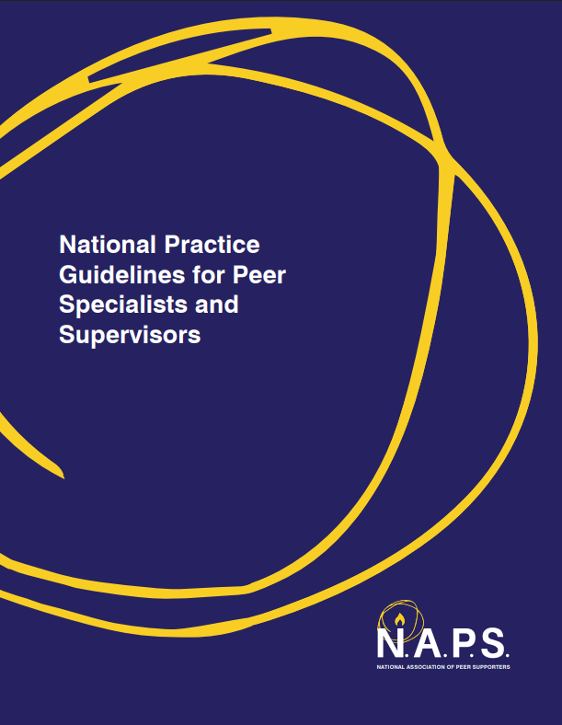
Substance Abuse and Mental Health Services Administration (SAMHSA)  Supervisor of Peer Workers Self-Assessment  In this resource, SAMHSA provides a framework for evaluating and enhancing supervisory practices within peer support programs. It includes tools and strategies to ensure effective, strengths-based supervision that aligns with recovery-oriented principles. | 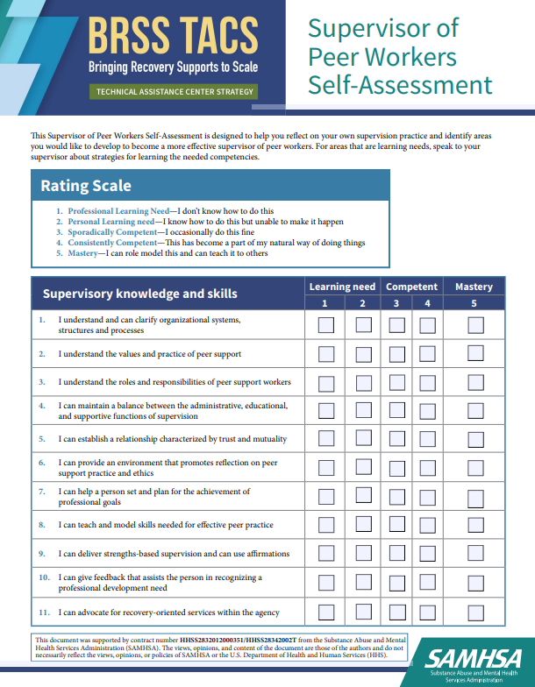
City of Philadelphia Department of Behavioral Health  Peer Support Toolkit  A toolkit offering practical guidance and resources for implementing and sustaining peer support services. It includes tools, strategies, and best practices to empower peer specialists and organizations in delivering effective, recovery-focused support. | 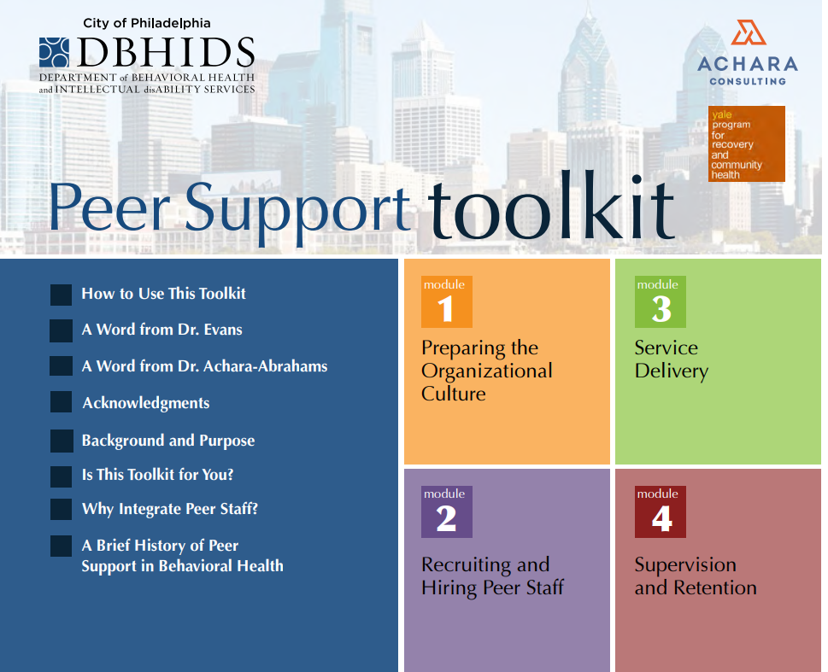
Georgia Mental Health Consumer Network  Supervisor Guide: Peer Support Whole Health and Wellness  A guide intended for supervisors that gives insights and strategies to effectively support peer specialists in promoting holistic health and wellness. It emphasizes the integration of peer support into healthcare settings to enhance recovery-oriented outcomes. | 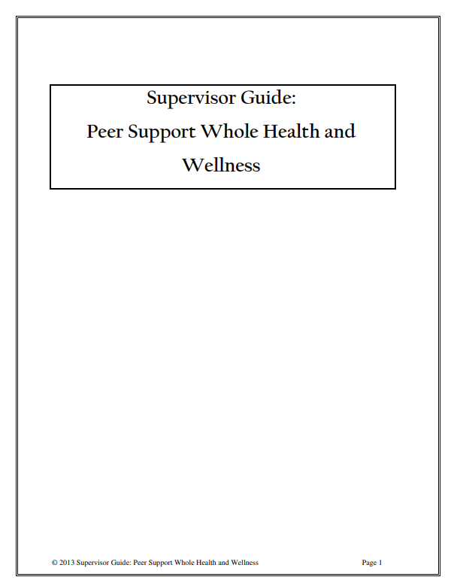

Offer to be part of a team focused on constructively outlining how supervision could best be structured within your specific agency.
If you see an opportunity for improved supervision within your agency, consider talking with agency leadership and offering to help create a peer team to gather constructive, positively framed feedback and suggestions.

