Module 1.1: Is This Your Calling?

Letter to Clinicians and Others to Explain Peer Role
Your organization can consider using or adapting this letter to help other agencies or professionals in your community better understand the peer role, purpose, boundaries, and value. This example was drafted with healthcare and clinical audiences in mind; you are invited to adapt the content to best suit your specific audience.
Dear Community Partner or [organization/individual’s name],
Our organizations have a shared interest in promoting health and recovery as we serve those in our community with substance use disorders who are pregnant or postpartum. We know that for many, pregnancy uniquely amplifies both the drawbacks and risks of active drug use, as well as the motivation to enter and maintain recovery.¹
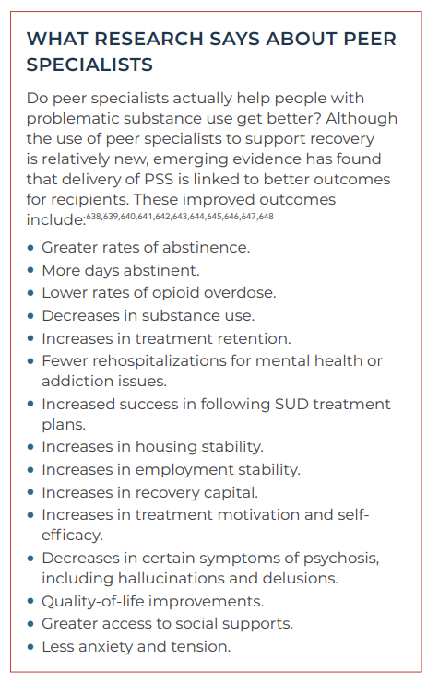
To be sure community resources are fully and efficiently used during this critical window for improving long-term health outcomes for women and their babies, we wanted to make you more aware of [organization name’s] peer recovery staff. By understanding more about their role, your organization will best be able to leverage the strengths and expertise of our peers who work with your patients. Optional sentence if you would like to list a specific peer/participant partnership: Specifically, our peer, _________, who is supervised by________________, is an engaged member of ______________’s ___________ team.

What is a peer [worker/specialist/coach]?
Peer support staff provide hope, encouragement, and recovery support services to a diverse population of program participants who have a range of behavioral health conditions and are at various stages of recovery. Drawing significantly on their personal experience with substance use, mental health, and improved health and wellness, our nonclinical peers apply their knowledge of local behavioral health services and other recovery resources to help link individuals to community resources as directed by that individual’s chosen recovery pathway. Peer support staff work closely with program intake staff, clinicians, social workers, and outreach staff.² Our peer workers often serve as motivational interviewers, engagement facilitators, role models and mentors, resource navigators, and recovery advocates. Years of research show that high-quality peer support services provide a high return on investment and increased efficiencies within our healthcare and treatment systems.^{3,4}

How can our organizations best collaborate to leverage our individual strengths?
Optional sentence: We know [recipient organization name] provides [complimentary statement about their work with P/PP]. If you would like to learn more about our organization, peer support staff, or discuss how we can best coordinate our services to pregnant or postpartum people in our community, we invite you to [insert options to learn more: visit our website at -----, attend one of our -------, call our (leadership role, name and contact info)]. We welcome any suggestions or questions you may have and look forward to continuing to work together in our community for the well-being of people who are pregnant or parenting and their children.
Sincerely,

References
1. Substance Abuse and Mental Health Services Administration (SAMHSA). Incorporating peer support into substance use disorder treatment services. Chapter 2—roles of the peer worker. Accessed Aug 27, 2025. https://www.ncbi.nlm.nih.gov/books/NBK596269/
2. Adapted from: City of Philadelphia Department of Behavioral Health and Intellectual disAbility Services (DBHIDS). Peer support toolkit. Accessed Aug 27, 2025. https://dbhids.org/wp-content/uploads/1970/01/PCCI_Peer-Support-Toolkit.pdf
3. Mental Health America. Evidence for peer support. Accessed Aug 27, 2025. https://mhanational.org/wp-content/uploads/2025/02/Evidence-Peer-Support-May-2019.pdf
4. Substance Abuse and Mental Health Services Administration (SAMHSA). Peers supporting recovery from substance use disorders. Accessed Aug 27, 2025. https://www.samhsa.gov/sites/default/files/programs_campaigns/brss_tacs/peers-supporting-recovery-substance-use-disorders-2017.pdf

