Updating Zoom Desktop App

- Enter this website enter your browser: https://zoom.us/client/5.15.6.21146/zoomusInstallerFull.pkg?archType=arm64
The Zoom client application will begin downloading on your browser

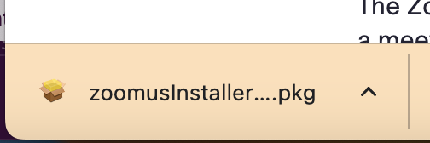

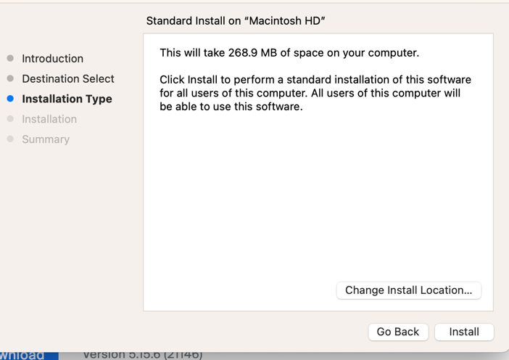
Click continue then Install.

- 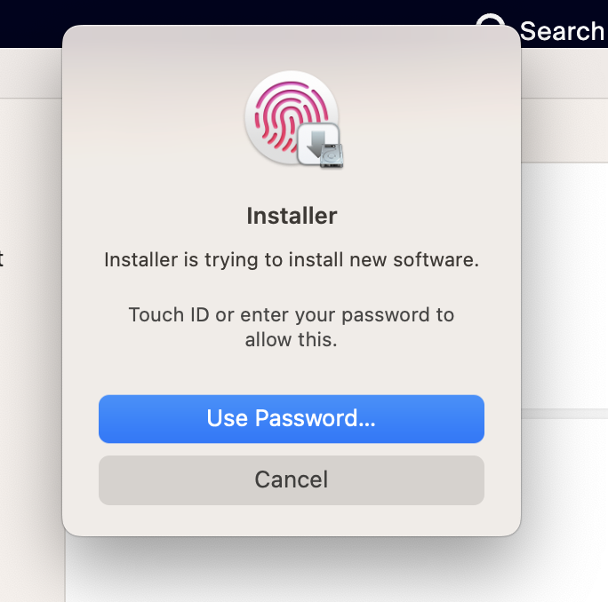
Enter Password

- Click “Close Application and Install”
- 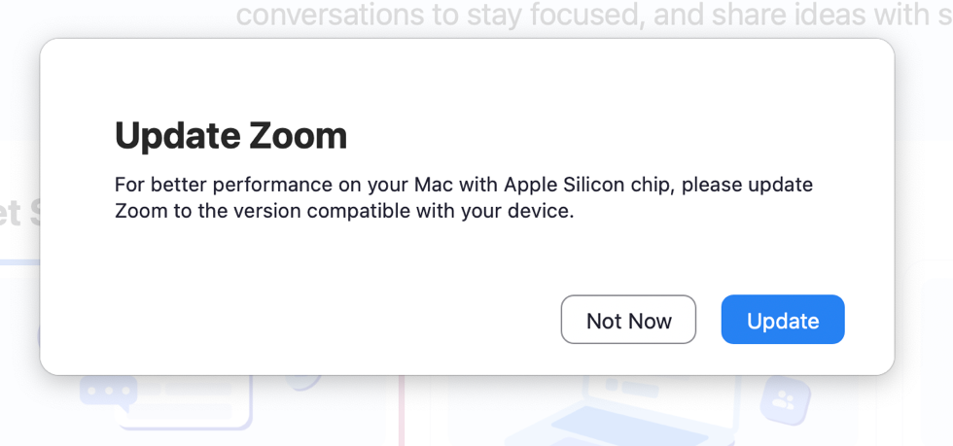
- 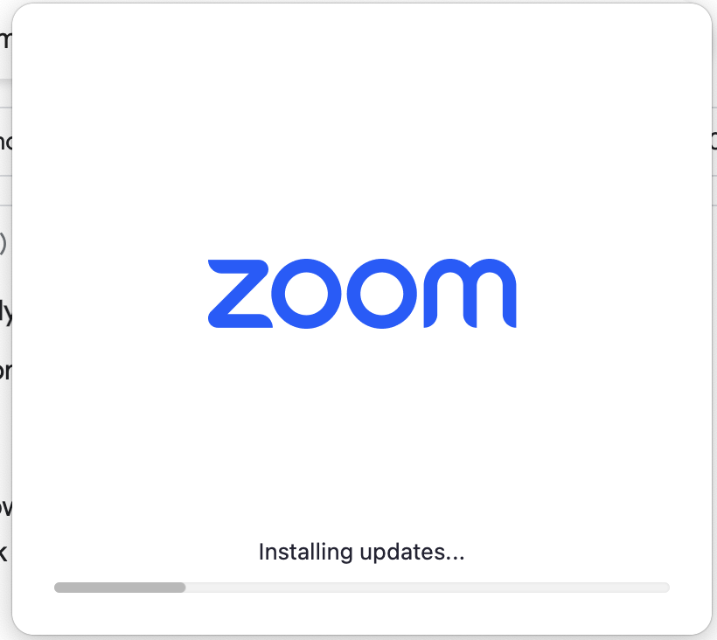
- 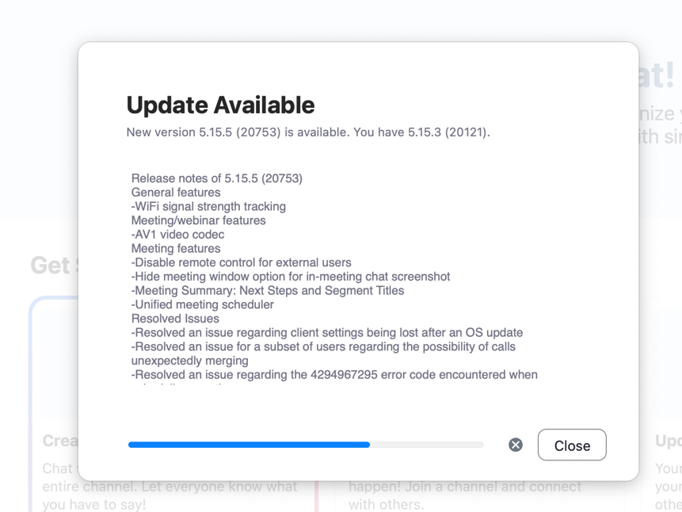
- Click through the screens and hit “install.”
- 
Wait for confirmation window on Zoom desktop app

